1980s: Samia Halaby
The 1940s mark the beginning of the climax of the tension between Palestine, Israel, and the Arab countries. From 1947 to 1949, the Palestine war was fought in the territory of mandatory Palestine. As a result, over 700,000 Palestinian Arabs fled or lost from their homes. This was over half of the pre-war Palestinian Arab population. Thousands of Palestinians lost their land. Many migrated to the neighbouring Arab countries.
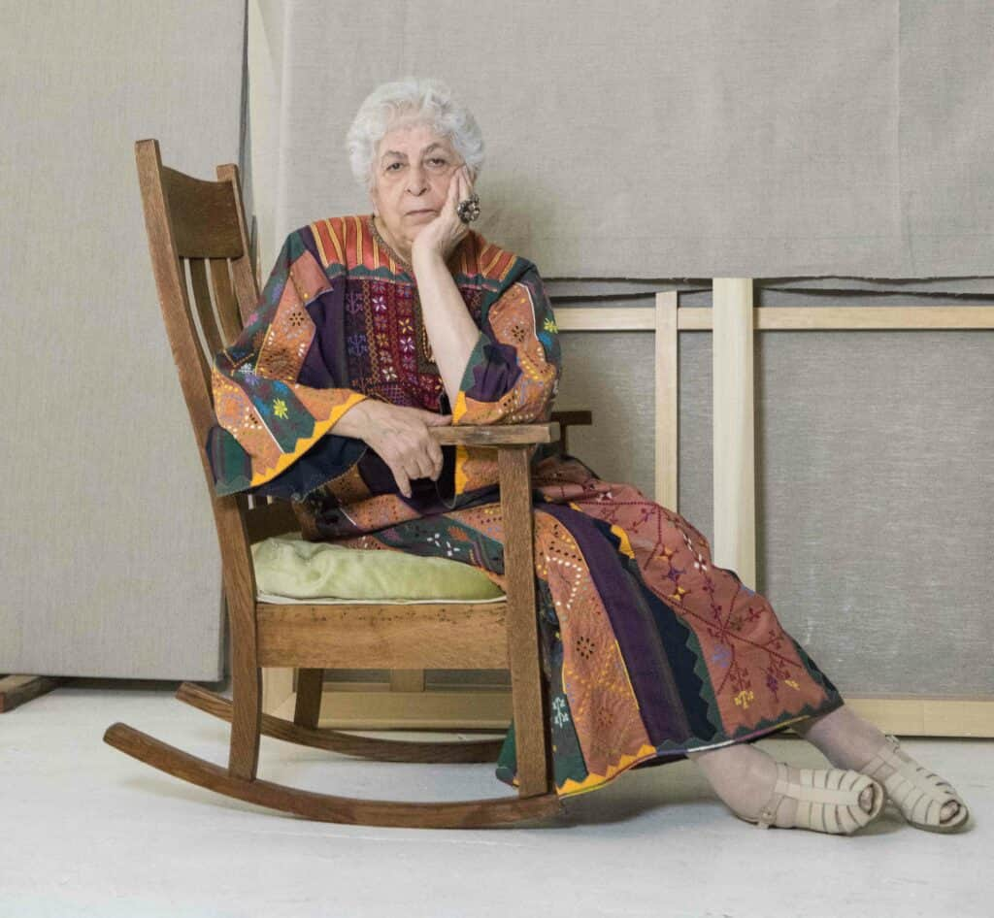
Samia Halaby and her family were displaced to Lebanon. The Palestinian-American artist was born in Jerusalem in 1936. After escaping to Lebanon, her father moved them to America. She is one of the many individuals growing up during the Nakba. This generation was shaped by the Nakab, an Arabic word for catastrophe. The Nakab is a day that is remembered until today.

Remembering Palestinian culture was a prominent feature for the Nakba generation. Arab countries attempted to eliminate the Palestinian identity as the people dispersed. The art emphasises Palestinian identity. It uses scenes from local villages and colours of the Palestinian flag.

In America, Halaby pursued her artistic career, encouraged by her family: “It was a love of making things that became focused through gentle remarks by my mother.” Halaby received her MFA at Indiana University when abstract expressionism was extremely popular. Her style draws from Arab abstraction, found in the Dome of the Rock and Aqsa Mosque in Jerusalem, as well as Twentieth-century abstract expressionism.

Halaby felt a strong need to remove the academic influences from her artistic practice. During the 1980s, Halaby developed her own abstract style. After this, her exposure into the art world began to grow when she exhibited herself in the Arab world. Today she lives in America, documenting the Palestinian struggle. She solely uses her paintings as an investigation into human meaningfulness without politics.

